Start your journey to becoming a Logan County Foster Parent.  - Contact our department of human services resource team to express your interest  - Complete and Submit an Application  - Attend Logan County Department and state-sponsored Core foster parent training  - Participate in a comprehensive family assessment  - Participate in ongoing training to help build your skills as a foster parent  Welcome to the Team!  Dear Prospective Parent,  Thank you for your interest in learning more about Logan County’s Foster Care Program. We applaud your desire to open your heart and home to your community’s foster children.  YOU have the opportunity to make a difference in a youth’s life. YOU have the capability to strengthen parents in our community and assist a child in returning home to a safe environment.  We understand this is a big commitment for your family, the rewards are real, and we hope that your family takes this chance to support our local kids.  Please contact us with the number listed on the back of this brochure if you have questions or would like to receive an application packet. We look forward to hearing from you!  Logan County Provides  - Monthly Support Meetings  - Specialized trainings  - Financial Assistance  - Monthly maintenance payments  - One time clothing allowance  - Medical insurance (Medicaid)  - Peer support from other foster parents  - Agency support from  - Caseworkers  - Case Aides  - Mental Health | 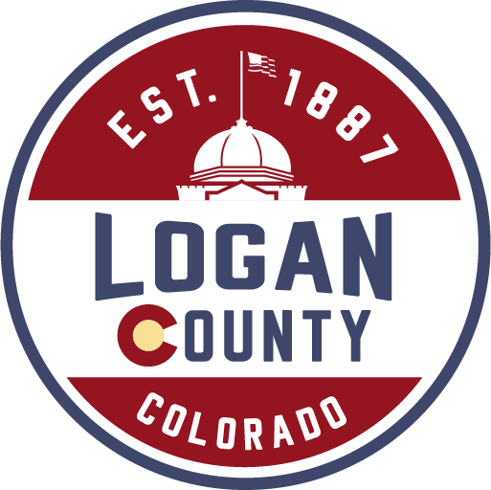  Call to learn more about how you can support children of all ages in your community.  Resource Unit  Logan County Department of Human Services  508 S. 10th Avenue Sterling, CO 80751  Phone: 970-522-2194  Nichole Lee ext. 2340 Nichole.Lee@state.co.us  Breanna Souffrant ext. 2970 Breanna.Kelsch@state.co.us Crystal Jackson ext. 2580 Crystal.Jackson@state.co.us  For more information, visit our website at:  https://www.loganfostercare.org  Did you know Foster Parents are…  - Single, married, or divorced  - With or without children  - Age 21 and older  - All income and education levels  - Men, Women, and LGBTQ  JUST LIKE YOU! | SUPPORT KIDS IN FOSTER CARE  YOU could be the missing piece.  Logan County Department of Human Services  970-522-2194 Extension 2340 or 2970  Step Out for Kids  This is a program ran by Logan County’s Child Welfare Resource Unit that supports Logan County’s kids who are in foster care.  Funding earned through this program has been used to:  - Pay for various camps  - Purchase sports equipment  - Pay for dance classes  - Help pay for class rings or letter jackets  - Provide training/support to families that provide care to our foster kids.  Interested in Helping?  Attend our annual Chili Supper and Silent Auction. Date and Location vary each year.  Or  Call and ask for other ideas

